Pokhara University

Level: Bachelor | Semester – Spring | Year : 2005
Programme: BE |  | Full Marks : 100
Course: Electronic Circuits |  | Time : 3hrs.

Candidates are required to give their answers in their own words as far as practicable.
The figures in the margin indicate full marks.

Attempt all the questions.

1. | a) Why Common Collector configuration amplifier is also called emitter follower? Verify your answer with the help of circuit diagram and necessary derivation.  b) According to the biasing condition, how can you classify the amplifier? Describe each type in brief. | 7  8
2. | a) The Class-A amplifier shown in figure is biased at V_{cq} = 12V. The output voltage is the maximum possible without distortion. Find,  i) The average power from dc supply  ii) The average power delivered to load from each supply.  iii) Power conversion efficiency.  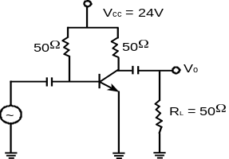  b) What is feedback? Describe different types of feedback amplifiers? | 8  7
3. | a) What is the Barkhausen Criterion for Oscillation? Design a RC phase shift oscillator to operate at a frequency of 5KHZ.  b) What do you mean by oscillator? What is the essential conditional condition for maintaining oscillations?  c) Calculate the approximate output voltage for the differential amplifier shown in of figure below. Take r_{e} = 25mV/I_{E} and neglect V_{BE}.  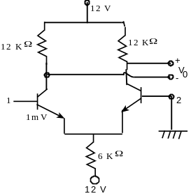 | 5  5  5
4. | a) What are the main characteristics and features of an Op-Amp?  b) Draw Schmitt Trigger Circuit. Explain its working principle.  c) Define the following terms: Virtual Ground, Output offset Voltage, CMRR and Slew rate. | 5  5  5
5. | a) What do you mean by logarithmic amplifier? Describe it with the help of circuit diagram.  b) Explain the operation of successive approximation A/D converter. | 7  8
6. | a) Describe the operation of full wave bridge rectifier with neat diagram, showing its input and output waveforms also. What are its advantages over half wave rectifier?  b) What are the different coupling methods used in multistage amplifier? Derive an expression for a gain of an n-stage amplifier in terms of decibel. | 5+3  7
7. | Write Short notes on (Any Two):  - R-2R ladder Circuit.  - Miller's Effect  - Instrumentation amplifier | 2x5

